

**Mathematics Applications  
YEAR 12**

**Investigation 2 – Pascal’s Triangle and Networks**

**Semester 1 2018**

**Time allowed:** 55 minutes

**Marks Available:** 50 marks

**Materials required:** Writing implements, correction fluid/tape or eraser, ruler, Scientific or CAS calculator

**Instructions:**

1. Write your answers in the spaces provided in this Question/Answer Booklet.
2. **Show all your working clearly**. Your working should be in sufficient detail to allow your answers to be checked readily and for marks to be awarded for reasoning. Incorrect answers given without supporting reasoning cannot be allocated any marks. For any question or part question worth more than two marks, valid working or justification is required to receive full marks. If you repeat an answer to any question, ensure that you cancel the answer you do not wish to have marked.

Be aware that this is an INVESTIGATION which is a process of discovery. Therefore findings made earlier in investigation can be used to support later findings. Show ALL working.

The following pattern represents the first six rows of the famous Pascal’s Triangle.

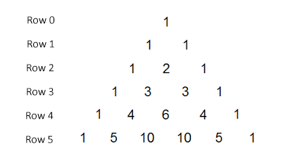

1. (3 marks)  
   **Explain** how rows 2, 3, 4 and 5 of the triangle are formed. **Demonstrate** using two examples to help with your explanation.
2. (4 marks)  
   **Complete** rows 6 - 9 of Pascal’s Triangle.

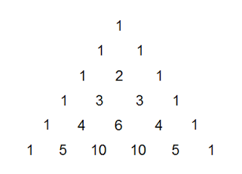

1. (6 marks)  
   Based on your research, **explain** three patterns that exist in Pascal’s triangle offering examples to **verify** your explanation.
2. (3 mark)  
   Diagonal 2 is formed by the numbers 1 2 3 4 5  
   **Describe** the difference pattern within this diagonal and **write** this difference pattern using sequence notation.

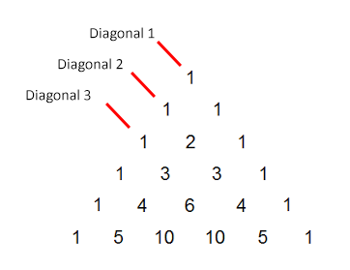

1. (6 marks)
   1. **State** the first five terms of the difference patterns for:
      1. Diagonal 3 [1]
      2. Diagonal 4 [1]
      3. Diagonal 5 [2]
   2. Do you notice any patterns? **Explain**. [2]
2. (6 marks)  
   Consider each of the five directed networks drawn below. Note the direction of travel arrows. You may only travel along each path in the direction indicated.

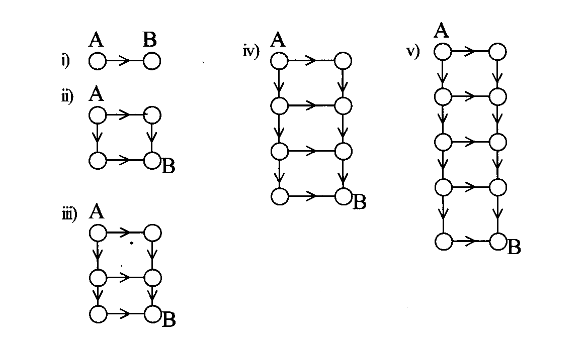

1. For each of the networks above, **determine** the number of ways of travelling from A to B (without any backtracking). **Record** your answers in the table below. [5]

|  |  |  |  |
| --- | --- | --- | --- |
|  | **Number of Columns** | **Number of Rows** | **Number of Ways from A to B** |
| **i** | 2 | 1 |  |
| **ii** | 2 | 2 |  |
| **iii** | 2 | 3 |  |
| **iv** | 2 | 4 |  |
| **v** | 2 | 5 |  |

1. **Predict** the number of ways of travelling from A to B for a network that has 2 columns and 10 rows. [1]
2. (3 marks)  
   Now consider the following networks:

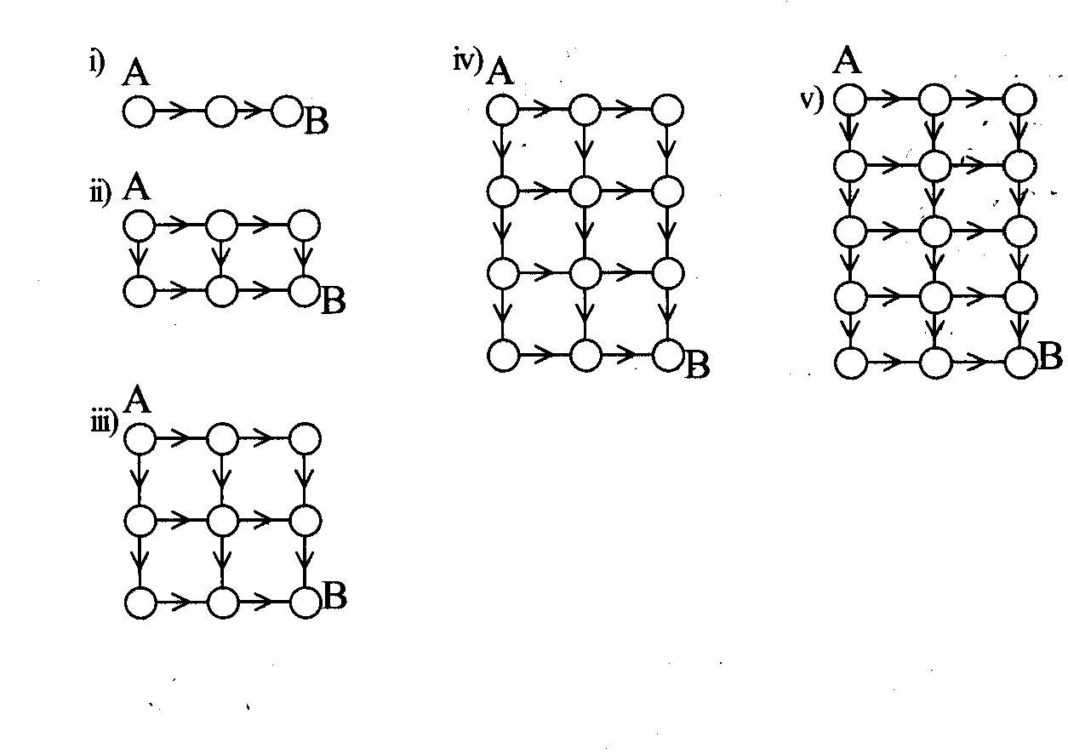

1. For each of the networks above, **determine** the number of ways of travelling from A to B (without any backtracking). **Record** your answers in the table below. [2]

|  |  |  |  |
| --- | --- | --- | --- |
|  | **Number of Columns** | **Number of Rows** | **Number of Ways from A to B** |
| **i** | 3 | 1 |  |
| **ii** | 3 | 2 |  |
| **iii** | 3 | 3 |  |
| **iv** | 3 | 4 |  |
| **v** | 3 | 5 |  |

1. **Predict** the number of ways of travelling from A to B for a network that has 3 columns and 9 rows. [1]
2. (3 marks)  
   Each of the following networks has 4 columns.

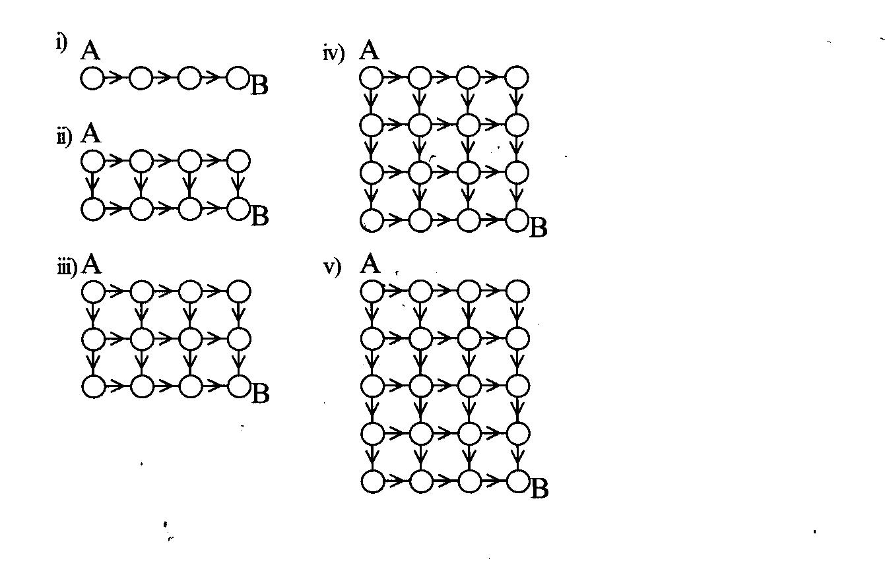

1. For each of the networks above, **determine** the number of ways of travelling from A to B (without any backtracking). **Record** your answers in the table below. [2]

|  |  |  |  |
| --- | --- | --- | --- |
|  | **Number of Columns** | **Number of Rows** | **Number of Ways from A to B** |
| **i** | 4 | 1 |  |
| **ii** | 4 | 2 |  |
| **iii** | 4 | 3 |  |
| **iv** | 4 | 4 |  |
| **v** | 4 | 5 |  |

1. **Predict** the number of ways of travelling from A to B for a network that has 4 columns and 8 rows. [1]
2. (3 marks)  
   **Compare** the sets of numbers created by the ‘number of ways’ column in each of your tables above with Pascal’s Triangle. What do you notice? **Verify** with examples to support your statement.
3. (2 marks)  
   Pete lives three blocks North and five blocks West of the school. The diagram below represents a map of the streets between his house and the school. How many different ways can Pete walk to school without backtracking (i.e. you are only allowed to move right and down)?

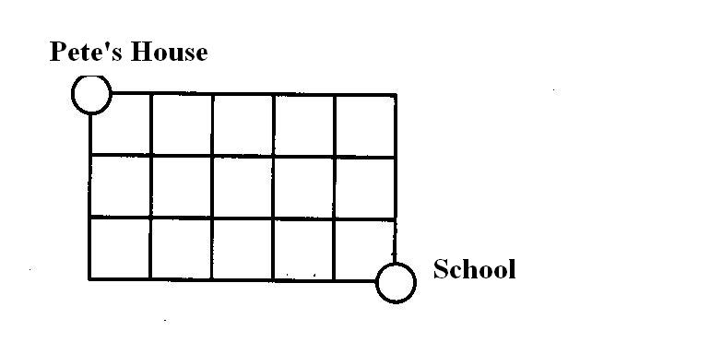

1. (3 marks)  
   How many ways can he travel to school if he must drop in at Jonathon’s house on the way through? Remember, you are only allowed to move right and down.

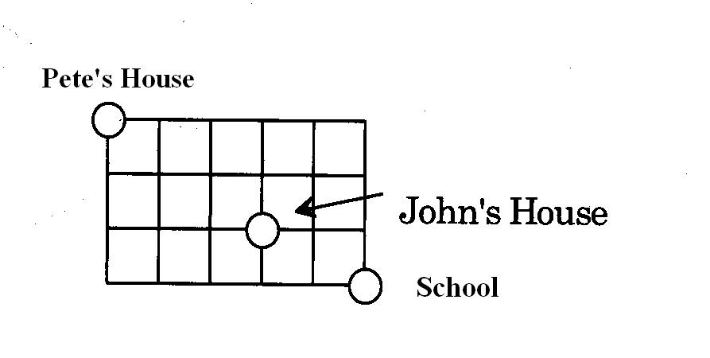

Questions continued over page…

1. (8 marks)  
   Using your knowledge from the networks explored and your tables or other systematic methods, consider the networks below.

|  |  |  |  |
| --- | --- | --- | --- |
| a) | 2 | b) | 1 |
| c) | 3 | d) | 4 |

Determine the number of ways of traveling from A to Z for each, without backtracking (i.e. you are only allowed to move right and down).

a) ______________ b) ______________

c) ______________ d) ______________

**End of Investigation**